A Statistical Study on the Correlation between the Determinants of CO2 Emissions

Zea Goh
Business Statistics Project
April 2023

Executive Summary
In view of the rising level of global CO2 emissions, policymakers around the world have been attempting to mitigate the problem to prevent further climate changes. However, to effectively
tackles the problem source, it is recommended for policymakers to first understand the relationship between those determinants, and how they affect the outcome of emission. Thus, in this statistical study, the correlation of the determinants: 1) country’s GDP per capita, 2) urbanisation, 3) population density, 4) share of renewable energy consumption has been analysed with the regression method and hypothesis testing at the 5% significance level was also conducted. Results have suggested that the determinants, GDP per capita, whether a country was highly urbanised, and its share of renewable energy consumption does affect the outcome of CO2 emission. However, results also suggested that the impact population density has on the CO2 emission levels are dependent on the other determinants. Further study with the inclusion of more independent variables, namely a country’s forest area, and its technological innovation stage, could be conducted in future for a better understanding and more conclusive evidence.

Introduction
In the initial report studying the CO2 emission levels in both high and low-middle income countries, findings had concluded that the emission level was higher in countries of high income.
Additionally, the CO2 emission was also observed to be higher in countries that were highly urbanised and densely populated. However, the results were not comprehensive enough in understanding how the determinants of CO2 emission would affect its outcome.
Therefore, in this second statistical analysis, additional factors of a country’s GDP per capita and share of renewable energy consumption will be included, with the aim of analysing if a correlation exists between those variables. By analysing the possible relationship between the CO2 emission and the variables, an understanding of how they affect the outcome of CO2 emission could be achieved, which would potentially aid policymakers in devising mitigation factors.

Analysis

1. Preliminary analysis of the correlation between CO2 emissions and following variables;
- Country’s Consumption rate of Renewable Energy
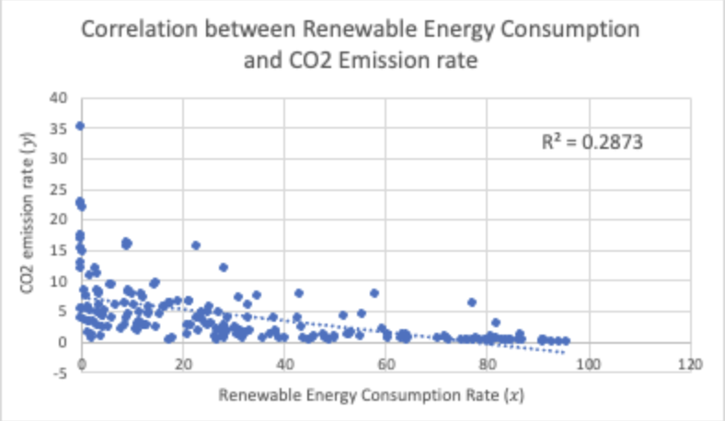
Figure 1a: Scatter plot illustrating the relationship between Renewable Energy Consumption and CO2 emission

As illustrated from the scatter plot in figure 1a, there is a moderate negative correlation between the 2 variables, renewable energy consumption and per capita emission of CO2. The trendline illustrates a downwards slope which indicates that when the rate of renewable energy consumption increases, the CO2 emission would inversely decrease.

- GDP of country
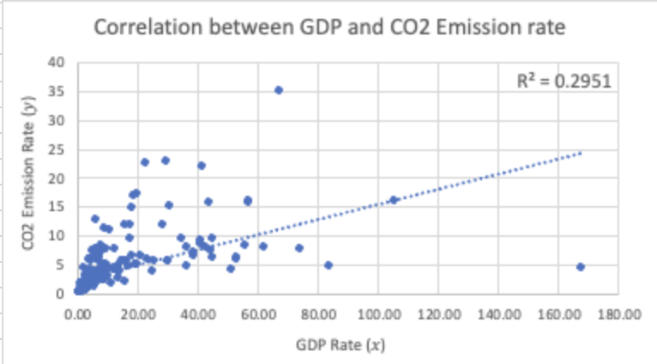
Figure 1b: Scatter plot illustrating the relationship between GDP and CO2 emission
As illustrated in Figure 1b’s scatter plot, there is a moderate positive correlation between a country’s GDP and CO2 emission. The upward trendline indicates that as the per capita GDP growth rate increases, the per capita CO2 emission increases as well.

- Urban and Dense
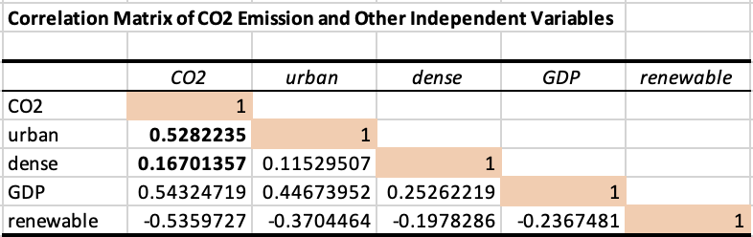
Figure 1c: Correlation Matrix illustrating the relationship between urban, dense and CO2 emission

The correlation matrix in figure 1c indicates that the variables urban and CO2 have a moderate positive correlation of value 0.528. While the variables dense and CO2 have a weak positive correlation of value 0.167.

2. Correlation between CO2 emissions and Renewable Energy (Simple Linear)
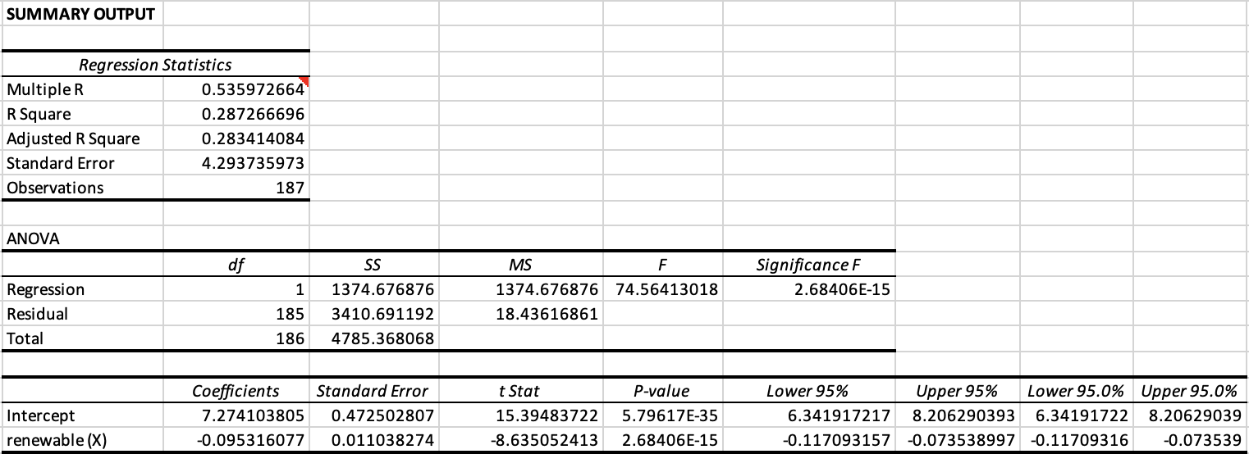
Figure 2.1: Simple Linear Regression model with Excel Data Analysis ToolPak (Model A)

Estimated regression equation:
$\hat{y}={β_{0}}_{}$+ $β_{1}x$
$\hat{CO2 emissions}=$7.274 - 0.095 (renewable energy consumption rate)

Interpretation of slope coefficient:
From the regression output generated with the Excel Data Analysis ToolPak, it is noted that the y-intercept, ${\hat{β}}_{0}$ indicates that when the rate of renewable energy consumption is at 0, the CO2 emission per capita is predicted to be 7.274.
Whereas the gradient, ${\hat{β}}_{1}$ indicates that for every 1% of renewable energy consumed, the CO2 emission per capita decreases by 0.0953.

2-tailed hypothesis testing using critical value approach (5% significance level):
Step 1 | H0: $β_{1}$= 0 (There is no linear relationship between the emission of CO2 and the consumption rate of renewable energy).  H1: $β_{1}$$≠$ 0 (There is a linear relationship).
Step 2 | t = $\frac{\hat{β_{1}}- β_{1}}{S_{{\hat{β}}_{1}}}$  $\frac{-(0.0953)- 0}{0.0110}$= -8.635
Step 3 | $df$ = $n$ - 1 - $k$  187 - 1 - 1 = 185 $⇒$ $±$1.96  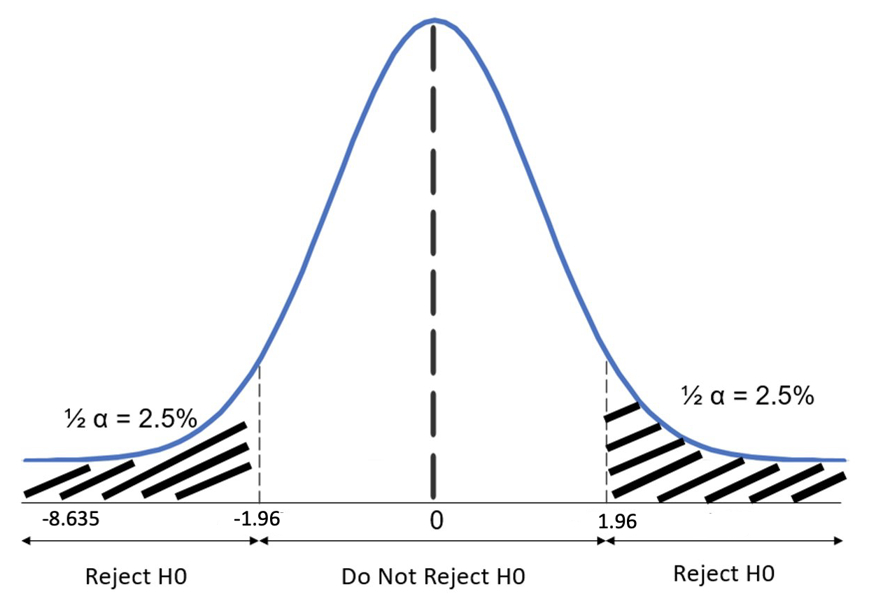  Figure 2.2 Distribution graph for t-test statistic  H0 is rejected, but we do not reject H1.
Step 4 | Thus, at the 5% significance level, there is sufficient evidence that there is a relationship between the emission of CO2 and the consumption rate of renewable energy.  This is consistent with the fact that R=0.536, indicating that there is a moderate direct correlation between the 2 variables.

3. Correlation between CO2 emissions and following variables (Multiple Linear Regression)

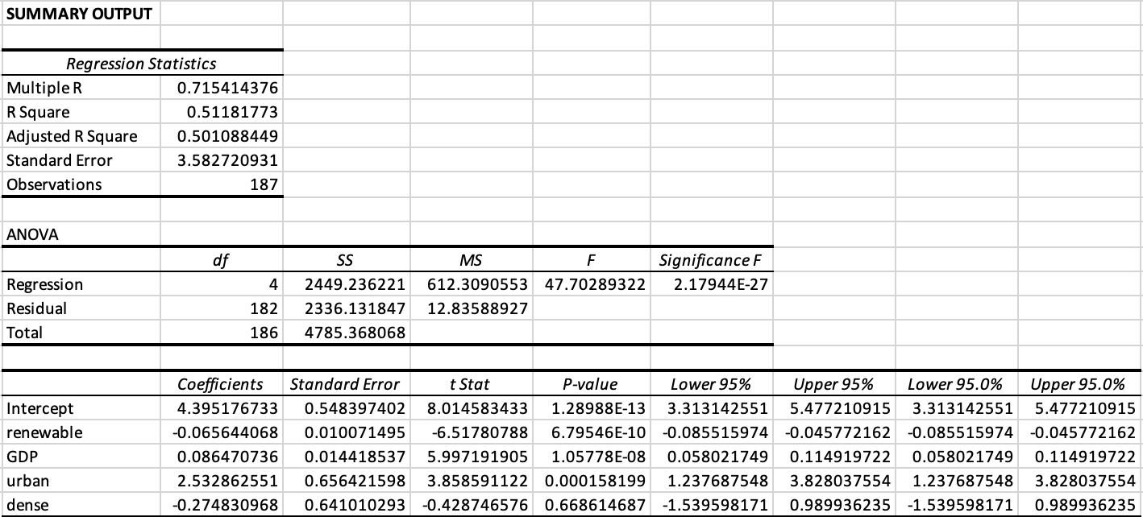
Figure 3.1: Multiple Linear Regression model with Excel Data Analysis ToolPak (Model B)

Estimated regression equation:
$\hat{y}={β_{0}}_{}$+ $β_{1}x_{1}$ + $β_{2}x_{2}$ + $β_{3}x_{3}$ + $β_{4}x_{4}$
$\hat{CO2 emissions}=$4.395 - 0.066 (Renewable) + 0.086 (GDP) + 2.533 (Urban) - 0.275 (Dense)

Interpretation of slope coefficient:
From the regression output, it is noted that the y-intercept, ${\hat{β}}_{0}$ indicates that when all the independent variables (renewable, GDP, urban and dense) are equivalent to 0, the predicted value of CO2 emissions per capita is 4.395. This makes sense as apart from the considered variables in this test, there are also other factors that potentially contribute to the emission of CO2, such as natural sources (volcanic activities, respirations etc.)
- The coefficient ${\hat{β}}_{1}$ indicates that for every 1% consumption of renewable energy, a decrease of 0.066 in the per capita CO2 emissions is observed, keeping GDP, urbanity and density rate as constant.
- ${\hat{β}}_{2}$ indicates that for USD1000 increase in the per capita GDP, there is an increase of 0.086 in the per capita CO2 emissions, keeping renewable, urbanity and density rate as constant.
- ${\hat{β}}_{3}$ indicates that in a highly urbanised country, there is an increase of 2.533 in the per capita CO2 emissions, keeping renewable, GDP and density rate as constant.
- ${\hat{β}}_{4}$suggests that in a densely populated country, there is a decrease of 0.275 in the per capita CO2 emissions, holding the variables renewable, GDP and urbanity rate as constant. Although results seemingly counterintuitive, and in contracts to the initial report which suggest densely populated countries emit a higher CO2, this is not entirely impractical as according to (Sung and Monschauer, 2020), densely populated countries tend to have a more developed and widely used public transportation system, reducing CO2 emission related to vehicle exhausts.

Individual variables 2-tailed hypothesis testing using p-value approach (5% significance level):
H0: $β_{1}$= 0 $⇒$ There is no linear relationship between each individual variables $(x_{i})$ and CO2 emission rate ($y$).
H1: $β_{1}$$≠$ 0 $⇒$ There is a linear relationship
Decision rule: If p-value <$α$ $⇒$ reject H0, if p-value $≥$$α$ $⇒$ do not reject H0.

- Renewable | P-value = 6.795E-10  Since p-value is within the rejection region ($≃$ 0 < 0.05),  H0 is rejected. Do not reject H1. At the 5% significance level, there is evidence of a linear relationship between renewable energy and CO2 emission.
- GDP | P-value = 1.057E-08  Since p-value is within the rejection region ($≃$ 0 < 0.05),  H0 is rejected. Do not reject H1. At the 5% significance level, there is evidence of a linear relationship between GDP and CO2 emission.
- Urban | P-value = 0.000158  Since p-value is within the rejection region ($≃$ 0 < 0.05),  H0 is rejected. Do not reject H1. At the 5% significance level, there is evidence of a linear relationship between urban and CO2 emission.
- Dense | P-value = 0.668614  Since p-value outside the rejection region ($≃$ 0.669 > 0.05),  Fail to reject H0. At the 5% significance level, there is insufficient evidence of a linear relationship between dense and CO2 emission.

Overall significance testing using p-value approach:
H0: $β_{1}$= $β_{2}$= $β_{3}$= $β_{4}$= 0 (There is no relationship between CO2 emission and any of the four variables).
H1: At least 1 of the $β_{i}$ $≠$0 (At least one of the variables affects CO2 emission).
P-value for overall significance = 2.179E-27
Since the p-value for overall significance is in the rejection region ($≃$ 0 > 0.5),
H0 is rejected. Do not reject H1. At the 5% significance level, there is evidence that at least one of the four independent variables affects CO2 emission.

4. Comparison of Coefficient between Model A (Simple Linear) and Model B (Multiple Linear)
Model A and B in comparison both note that the coefficient of renewable are of a negative value, indicating that the consumption of renewable energy decreases the per capita emission of CO2. However, there is a slight difference in the coefficient value which suggests that the consumption of renewable energy has more impact in reducing CO2 emissions in Model A than in Model B. Difference in the coefficient value could be due to the presence of the other independent variables taken into consideration in Model B, as compared to Model A. In the context of this statistical study, a Model B is better as it takes into account the various determinants of CO2 emission, which is crucial in analysing the complex relationship between the multiple independent variables and how they impact the dependent variable, CO2 emission level.

5. Estimating and Comparing Multiple Linear Regression Model for HICs and LMICs
a) Correlation of independent variables and CO2 emission in HICs

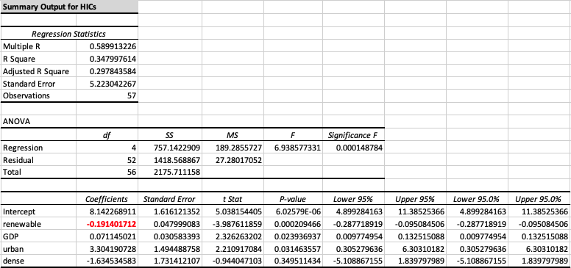
Figure 4.1: Summary output for HICs (Model B)
b) Correlation of independent variables and emission of CO2 in LMICs
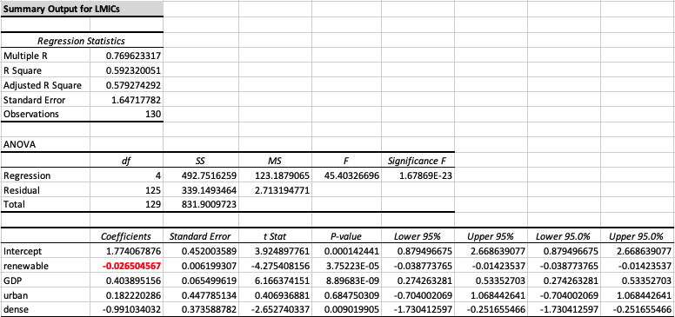
Figure 4.2: Summary output for LMICs (Model B)

Comparing both models illustrated in figure 4.1 and 4.2, it is observed that for every unit increase in the country’s consumption of renewable energy, the CO2 emission is expected to decrease in both HICs and LMICs. However, their values vary according to the country group. In HICs, the CO2 emission decreases by 0.191, while LMICs decreases by only 0.027. One possible reason for the difference could be that since HICs are more highly developed and technologically advanced than LMICs, they would tend to have more developed infrastructure to support production and consumption of renewable energy which would effectively lower CO2 emission.

6. Predicted CO2 emissions in the following scenarios:
- Densely and highly urbanised HIC with 20% of renewable energy out of total energy consumption, and per capita GDP of USD 40,000.
$\hat{CO2 emissions}$ = 8.142 - 0.191(20) + 0.071(40) + 3.304 - 1.635
= 8.831 metric tons per capita

- Densely and highly urbanised LMIC with 20% of renewable energy out of total energy consumption, and a per capita GDP of USD 4,000.
$\hat{CO2 emissions}=$1.774 - 0.027(20) + 0.404(4) + 0.182 - 0.991
= 2.041 metric tons per capita

7. Additional Variables to Consider
Apart from the 4 independent variables in this study, there are several other variables that have been posited as impactful on the global CO2 emission levels, and could be considered in the regression study.
Variable 1: Forest Area
The first independent variable that could be introduced, country’s forest area per square feet. Trees are known to naturally absorb CO2 from the surrounding atmosphere, which helps to reduce the CO2 emission level (National Parks Board, 2023). It is predicted that this variable would have a negative correlation with CO2 emission, and that for every square foot of area with trees in the country, the CO2 emission would decrease. Thus, the direction of the trendline would be downward sloping.
Variable 2: Technological Innovation and Advancement Stage
The second variable that could be considered would be the technological advancement stage of a country. This could be measured as 1= highly advanced, 0= not advanced. Research has shown that technological innovations help in reducing CO2 emission by improving production and consumption of efficient energy (Liu et al, 2022). Hence, similar to the first variable, it is predicted that variable 2 would have a negative correlation with CO2 emission, and for every country that is technologically advanced, the CO2 emission would decrease. Thus, the direction of the trendline would be downward sloping.

Conclusion
In conclusion, results inferred from the simple linear regression model and t-statistic hypothesis testing indicated that there is a relationship between renewable energy and CO2 emission.
Likewise, results inferred and tested from the multiple regression model indicated that three of the hypothesised determinants, consumption of renewable energy, urbanity of country and GDP per capita, affects the outcome of CO2 emission due to their existing linear relationship.

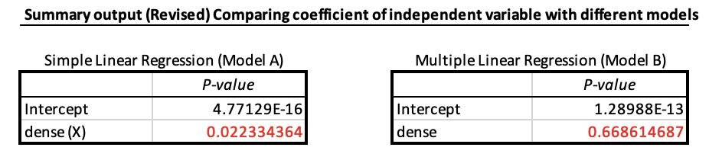
Figure 5: Comparison of the p-value results of variable dense between a Simple Linear Regression Model and a Multiple Regression Model

Interestingly as illustrated in figure 5, the population density variable in a simple linear regression model showed evidence of a linear relationship between population density and CO2 emission, however when tested in the multiple regression model, contrasting results were observed. This could suggest that the impact population density has on the outcome of CO2 emission is dependent on the presence of the other independent variables and the significance of it could be affected by multicollinearity (Frost, 2017).
Lastly, for the multiple regression overall significance test, results suggested the added independent variables in the multiple regression analysis are statistically significant and affect the outcome of CO2 emission. Therefore, policymakers would wish to examine the determinants of CO2 emission closely to strategise a way to tackle them with the aim of effectively lowering global emissions levels.

References
Frost J (2017), Multicollinearity in Regression Analysis: Problems, Detection, and Solutions, accessed 11 April 2023, StatisticsbyJim website, https://statisticsbyjim.com/regression/multicollinearity-in-regression-analysis/

Liu Y, Tang L, and Liu G (2022), ‘Carbon Dioxide Emissions Reduction through Technological Innovation: Empirical Evidence from Chinese Provinces’, International Journal of Environmental Research and Public Health, 19(15):9543, MDPI Open Access Journals website, accessed 10 April 2023, https://www.mdpi.com/1660-4601/19/15/9543

National Parks Board (2023), Benefits of Trees: Find out why trees are so important to people and cities, accessed 10 April 2023, TreesSG website, https://www.nparks.gov.sg/treessg

Sung J and Monschauer Y (2020), Changes in Transport Behaviour during the Covid-19 crisis, accessed on 9 April 2023, IEA website, https://www.iea.org/articles/changes-in-transport-behaviour-during-the-covid-19-crisis

